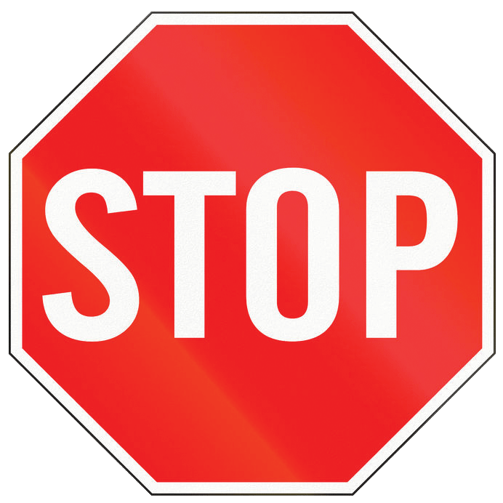
Please stop and clean your hands!
Germs get in here via people's hands… and can make our residents very sick.
Thank you for caring for your loved ones!

