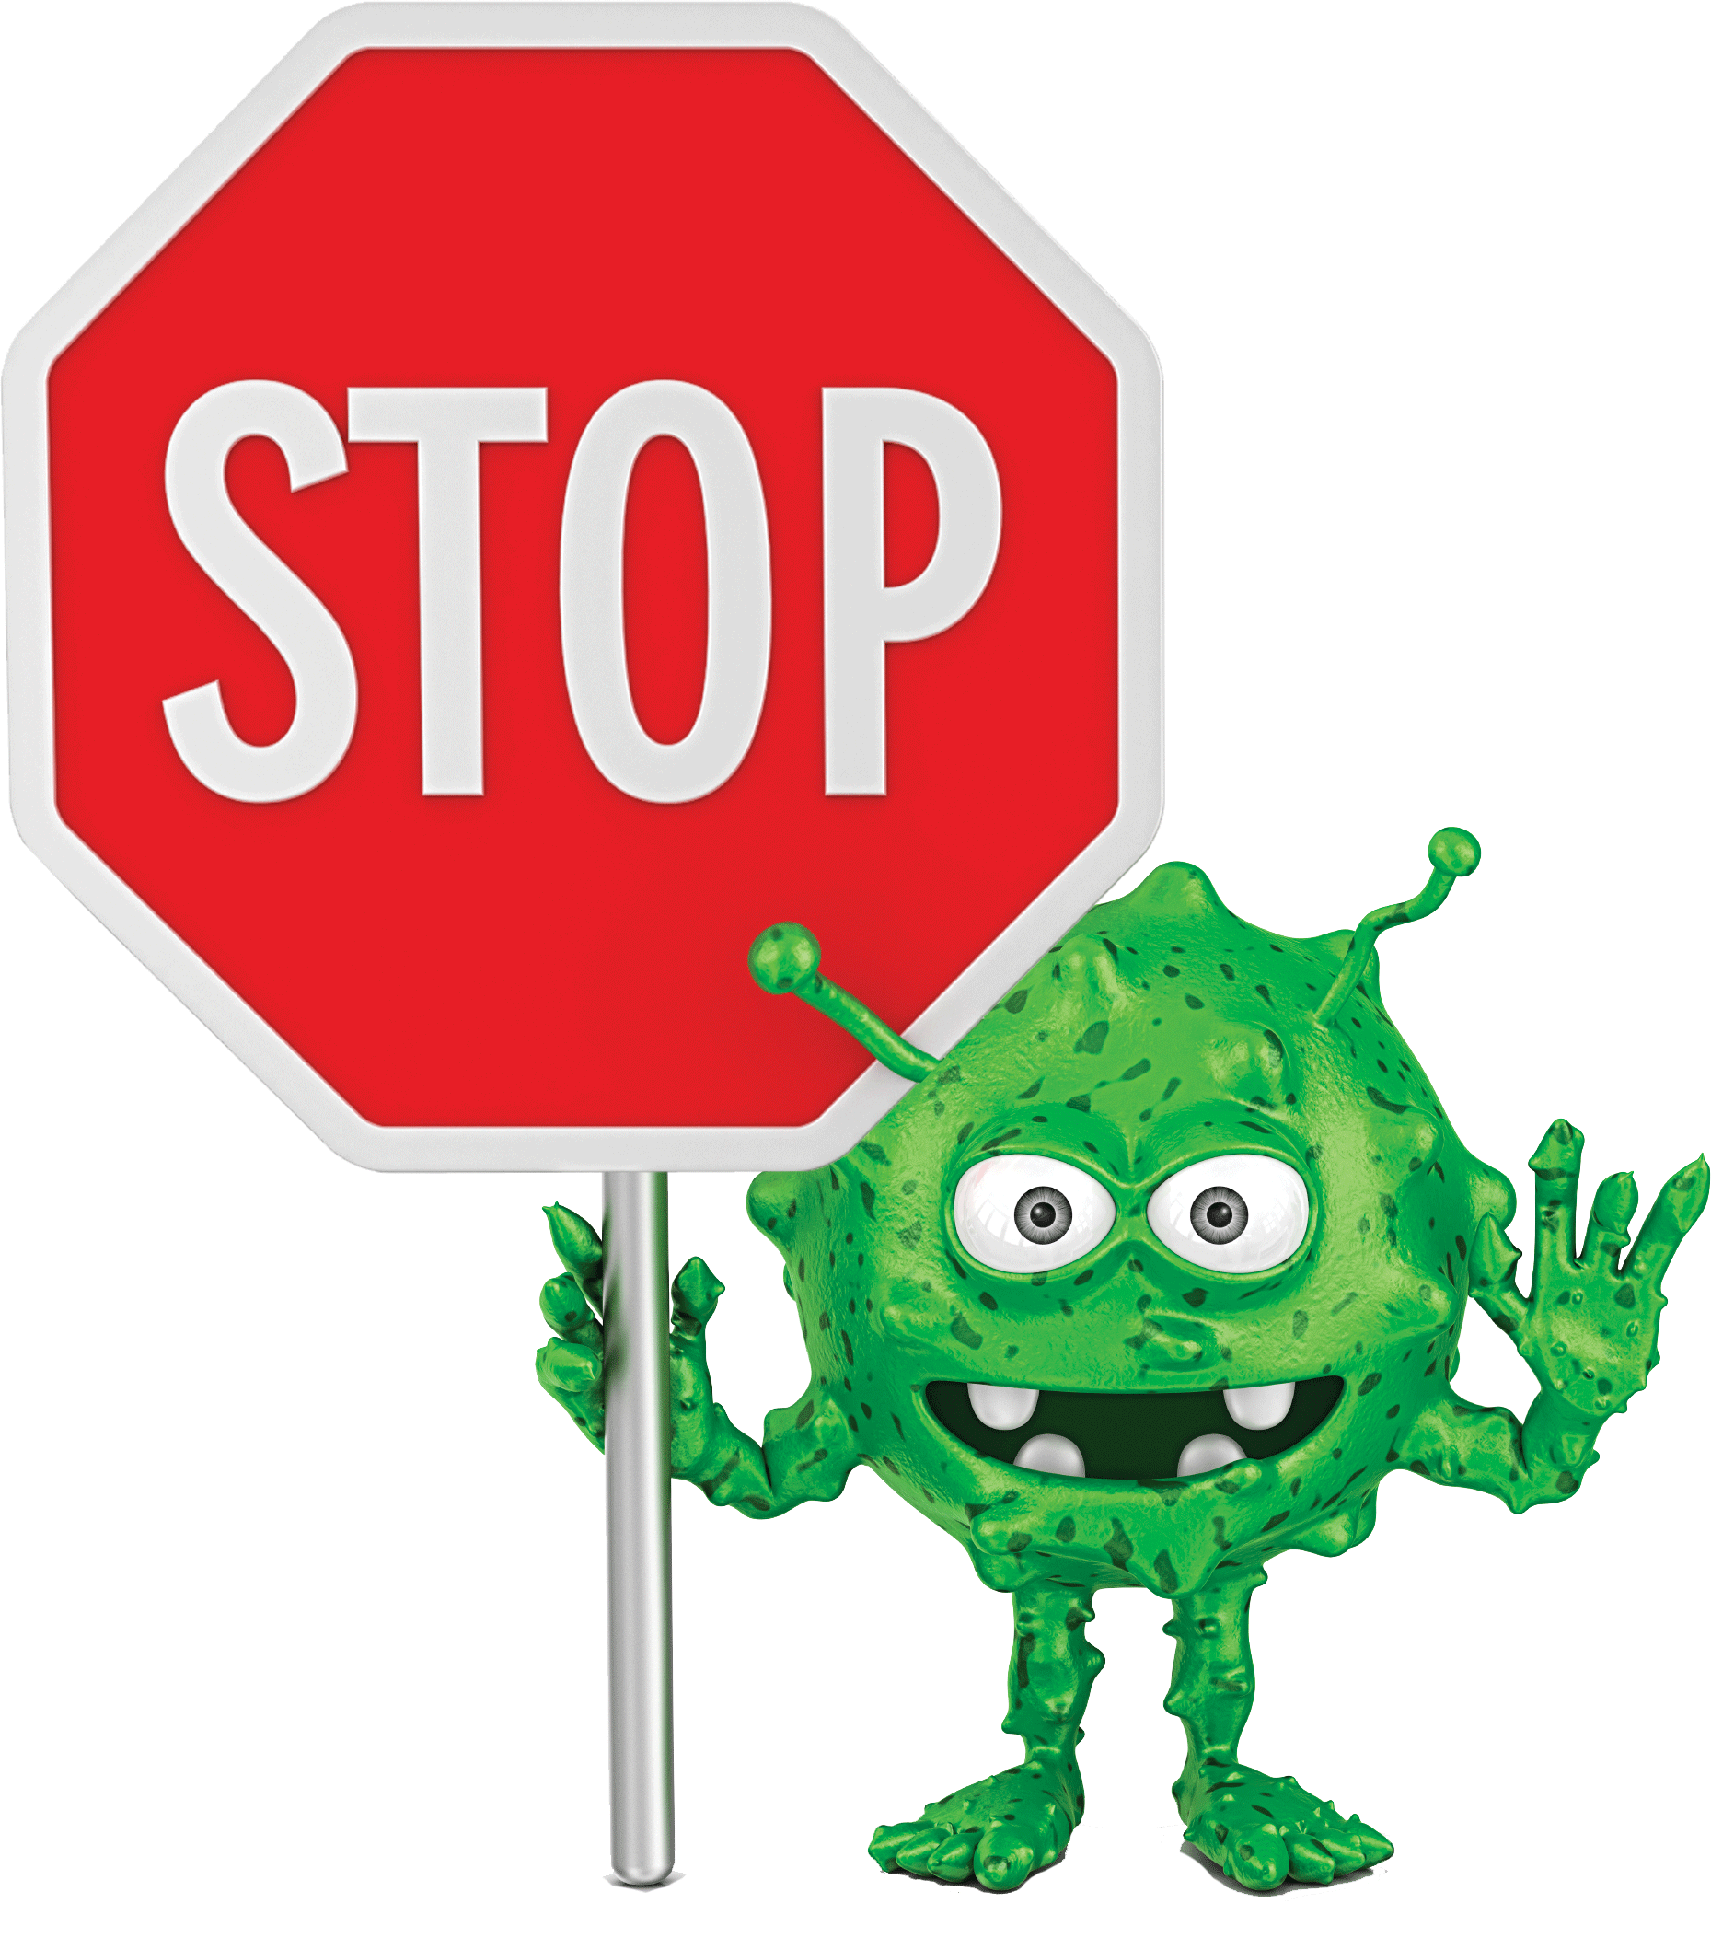
Please stop and clean your hands!
There are germs on your hands… you just can't see them! These can make our residents very sick.
Thank you for caring for your loved ones.

